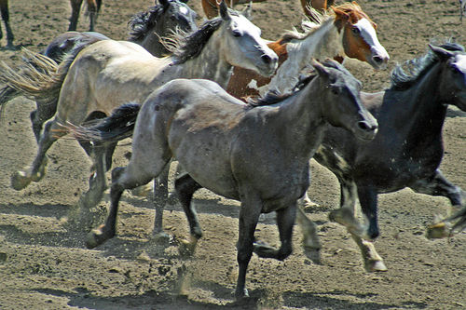
Stampede Spirit Week

Monday, October 1st PJ Day
Tuesday, October 2nd Tie Tuesday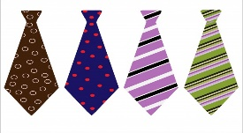
Wednesday, October 3rd Sports Day Thursday, October 4th Hat Day Friday, October 5th McCarty Day
Stampede Day

