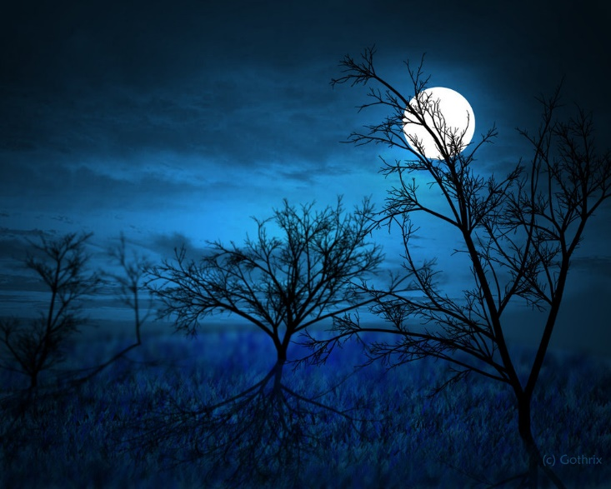

**Costumes are welcomed, but Not Required.**

**Please no masks.**

**Halloween Dance**

**Friday, October 19th**

**6:30-8:30 PM**

**Neuqua Valley Birkett Center**

**Forum Room**

**Tickets go on sale Tuesday, October 9th**

**$5.00 in advance**

**$7.00 at the door**

**Pizza, chips, cupcakes, and drinks will be served.**