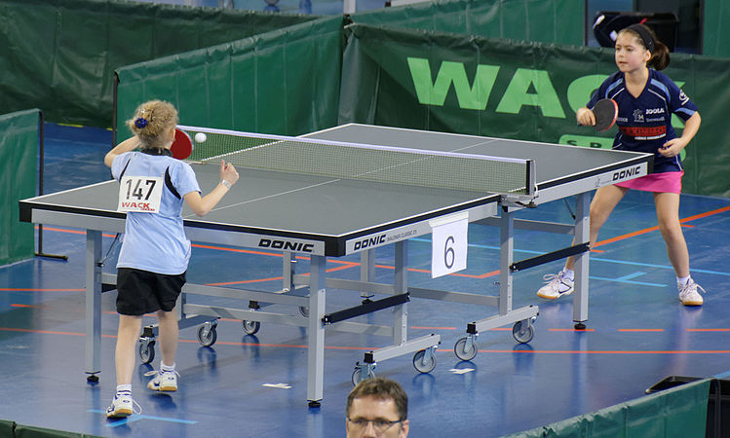
Intramural Ping Pong
Starting Monday. 10/15.
Monday & Wed.
Time: After School 3PM
Place: By Vending Machines
Everyone is welcome.

