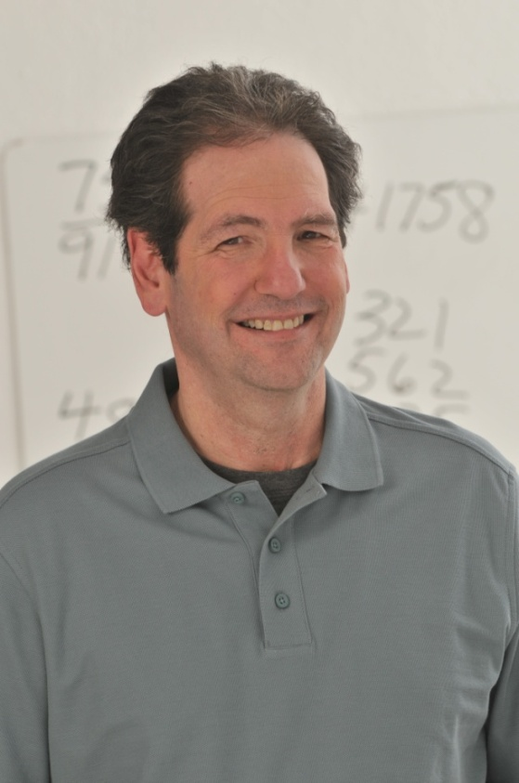
About Mike Byster (2017 Superhuman Winner on FoxTV)
Talk to Mike Byster for 10 minutes and he will change the way you think about learning forever. With his contagious enthusiasm and passion for math and memory, he will prove that not only are you able to expand your mind, but you will have fun doing so. With one of the fastest mathematical minds on the planet, Mike receives thousands of calls each year from schools requesting him to visit and share his knowledge. He has visited over 16,000 classrooms, nursing homes, and businesses worldwide, and he does so for free.

Watching Mike do huge math equations in his head—even faster than a calculator—is extraordinary. To see kids do exactly the same thing is life changing. But Mike was not born a genius. He broke learning skills down into simple easy to follow steps, which are not taught in schools. Skills that every student needs for success. In doing so, he wants to empower individuals to be able to reach their full potential. (www.mikebyster.com)

Mike’s mission in life is to positively impact the minds and lives of students ages 9-99. From test anxiety and learning disabilities to head injuries and Alzheimer’s, Mike’s approach to learning turns the pressure off, making the process of learning a positive experience. Mike has literally written the book on mental math, memory, focus, concentration, and organization skills. His book, ”The Power of Forgetting”, and learning tool, “Brainetics”, were born from his love of learning and his own struggles in school. He created Brainetics so the entire family can have a great time while learning at home. Brainetics (an engaging 5 DVD set, that is in a game show format) is the winner of the 2008 Parent’s Choice Award, 2012 Mom’s Best Award, and 2015 Academics’ Choice, “Brain Toy” Award.

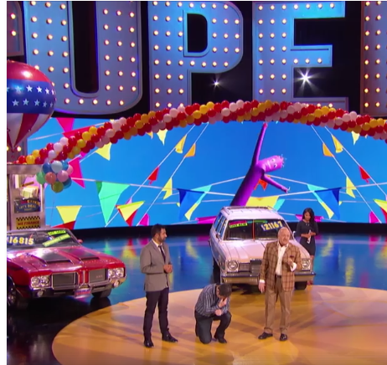
A native of Chicago, Mike earned his Business degree at the University of Illinois and he is a member of the National Council of Mathematics Teachers and Mensa.

ABC's 20/20 in an investigative report says,“He turns average kids into whiz kids.” Fun fact: After Mike was featured on 20/20, the program received more emailsthan any other segment previously aired.

Winner of the title, “Superhuman”, this season on Fox, he has also been featured on “Windy City Live”, The Hallmark Channel’s “Home and Family”, WGN News, Reader’s Digest, Bloomberg News, NPR, Chicago Tribune, Chicago Sun Times, Atlanta-Journal Constitution, The Gayle King Show, Bulldog in the Morning Show, Jenniffer Weigel’s, “I’m Spiritual”, Paul Lisnek’s, “Behind the Curtain” and several local and regional media channels across the country.
Please visit www.mikebyster.com, https://youtu.be/d66hgttVL6M and https://www.youtube.com/watch?v=WS5dlqXkPRw to see him in action.

