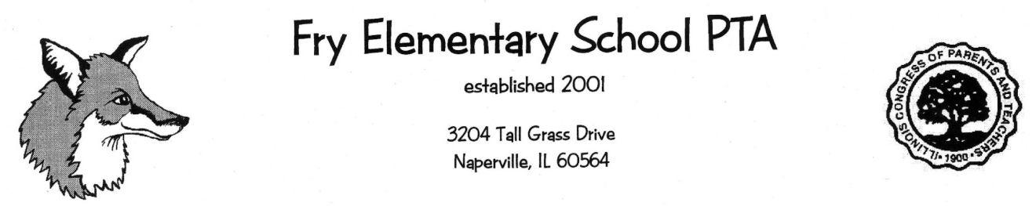

Student Name________________________________ Gender (circle) M or F

Teacher Name & Grade Level_________________________________________

Email address____________________________________________________

Parents’ Names___________________________________________________

Home phone #_________________________Cell #_____________________

*************************************************************************
Does your child have food allergies? Yes or No. ______ (If yes, please list below)

______________________________________________________________

Are these allergies listed with the school nurse?_____________ Yes or No.
**************************************************************************
Each child will need a Junior Great Book.

_______I need to order a NEW book (cost $25)
_______I have the book and do not need a new one. (cost $5)
_______I would like a used copy - available only for 2nd grade ($5, supply is limited so this is first come, first served)

_________________________________________________(parent signature)
Please enclose a check, with your child’s name on it, for $25 (needing a book) or $5 (not needing a book) made out to FRY PTA. Each child requires their own form and check. If you have multiple children, please submit each separately. Return this page with a check in an envelope to your child’s teacher by November 30, 2018. Please do NOT staple the check to the form.

