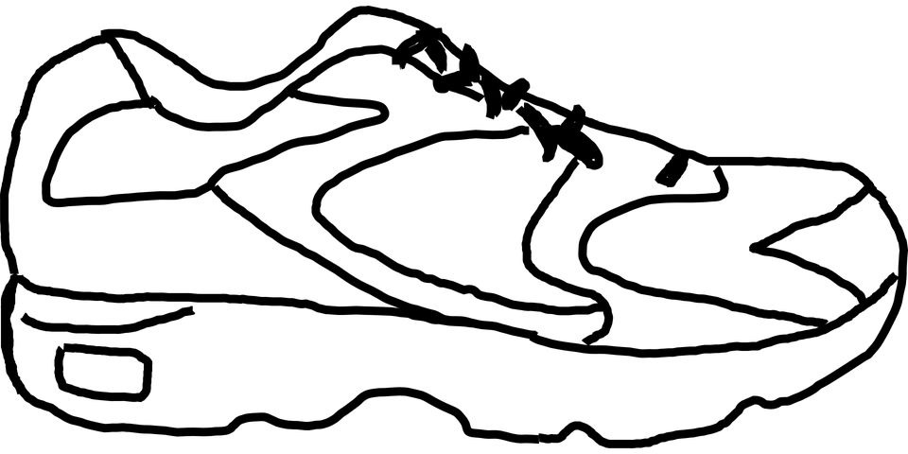
Georgetown Running Club

Who: All Boys & Girls in 3rd, 4th and 5th Grade

What: Participate in Georgetown Running Club and 5th Annual 5k (The race will be held on the last session on May 24th parents are required to attend on race day)

When: After school (3:35-4:30) on Mondays & Wednesday April 8th- May 20th (6 Weeks)

Cost: $12:00 (Running shirt, medals and snacks on race day. Please include this with your permission slip.)

Where: Georgetown! Practices will take place outdoors unless temperature is below 40 degrees or raining. Appropriate attire is required for safe participation.
DETAILS
- Permission slips are due to classroom teacher by Friday, March 15th.
- Students are encouraged to wear running clothes to school. Students can bring a change of clothes appropriate for weather and for exercise as well as gym shoes/running shoes and athletic socks. However, students will be allowed to change into their running clothes after school.
- All participating students MUST be able to attend 12 out of 13 practices. If more than one session will have to be missed, please refrain from signing up this year. Thanks!
- Parents/guardians must arrange for prompt pick-up for their participating child at 4:30 pm.
- No running experience needed! Practices will focus on building self-esteem and healthy habits. Students will learn about stretching and will build running endurance.
- We will have a 5K event at the end of the 5 weeks. A Parent/ Guardian is required to attend and family members are encouraged to run with their child! (More information to come!)
Coaches- Mr. Havinga, Miss Johns, and Ms. Lanning

Due by Friday, March 15th
Please PRINT information neatly and in ink:

Participating Child’s First & Last Name Home room teacher
__________________________________________________________________

Please list any relevant medical issues (asthma, etc):
_______________________________________________

Emergency Contact Information while your child is participation in Running Club:

Contact Person’s Name:_____________________________________
Contact Person’s Phone Number:_____________________________
I am available to volunteer yes____ no_____

Alternate Contact Person Name_____________________________
Relationship to Child:_______________________________________
Contact’s Phone Number ____________________________________

Please indicate how your child will get home:
Pick-Up_______ Child will walk home_____

Indicate your child’s shirt size:
Youth Sizes  Small_______  Medium_____  Large ______ | Adult Sizes  Small ______  Medium_____  Large_______  X-Large _____

Please sign below signifying you give your child, _____________________ permission to participate in the Georgetown Running club on Mondays and Wednesdays after school.
Parent/ Guardian Signature:_______________________________
Student Signature:______________________________________

NOTE: Please remember to enclose your $12.00. Thanks!

