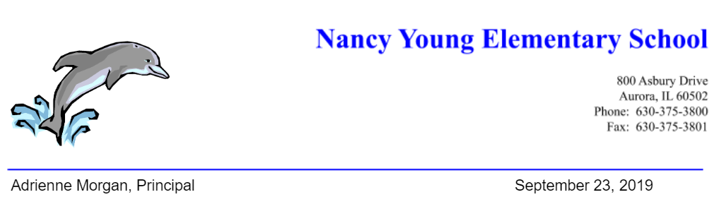

On Friday, October 4 from 6-8 PM, Nancy Young Elementary staff will be hosting a Parents’ Night Out to benefit all staff members running in the 2019 Healthy Driven Naperville Half Marathon & 5K on Sunday, October 20. Students will be dropped off at school and supervised in activities by Young staff that will participate in the event. This event is for currently enrolled Young students.

Drop off begins at 5:45 PM and pick up is at 8:00 PM.

The cost is $10 per child. Please fill out the form below and donate $10 cash or check made payable to Nancy Young Elementary inside an envelope marked "Parents Night Out." All students that participate will receive a Parents Night Out Super Coupon.

Parents’ Night Out Student Expectations
Respect Yourself  - Showcase Your Best Behavior  - Raise Your Hand for Help | Respect Others  - Keep Hands and Feet to Yourself  - Listen and Follow Directions  - Be Mindful of Others | Respect Property  - Clean Up Your Area  - Leave Electronics at Home

Thank you Team Young Staff Runners,
Robert Bell (student service coordinator), Matthew Cooper (PE), Karina Lebonserger (social worker), Terona Haley (3rd grade), Kim Lally (secretary), Roberto Maldonado (PE), Monika Miller (special education), Tony Pape (music teacher), Christine Ryan (reading), Tanya Shea (psychologist), Chris Delgado (teacher assistant), Priya Sriram (teacher assistant), Jenna Steinke (speech language pathologist), and Mary Zalabak (special education)
________________________________________________________________________________

Parents’ Night Out Permission Slip (10/4)
- Yes. My child will attend to attend Parents’ Night Out on Friday, October 4 from 6-8 PM. My child and I have read and understand the behavioral expectations for this event.

Child(ren) Name(s):______________________________________________________

Parent Signature (Please print name):________________________________________________________

Cell Phone Number: ________________________________________________________

