Parent/Teacher Conference Sign-up through Power PTC

Parent/Teacher conferences will be held on Thursday, November 21st from 4:30 PM- 8:00 PM and on Monday, November 25th from 8:00 AM-3:00 PM and 4:30PM-8:00 PM.

Parents are encouraged to sign up for conferences through their child(ren)’s Home Access Account. Please see the instructions below for scheduling a conference.

**Scheduling a Conference**

Conferences will be scheduled through your eSchool Home Access account. Parents must have registered for the HAC account in order to use the PowerPTC resource. Once logged to your HAC account, from the home screen select **School Links** and click on **PowerPTC- Online Conference Scheduler** (see screenshot below).

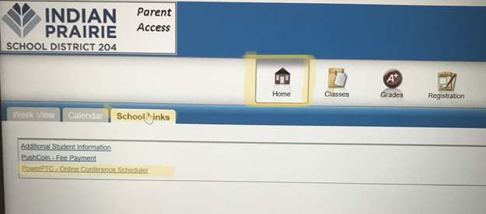

Parents will log on to PowerPTC with the same credentials as their HAC account. Once in PowerPTC, select **Conference Schedule** to view available dates and times to schedule conferences with available teachers for your child only.

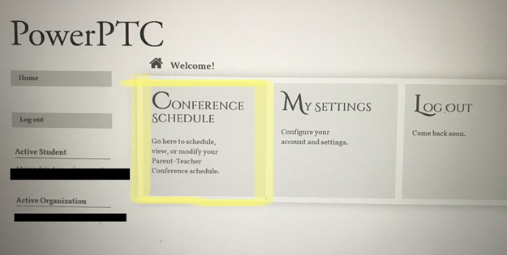

Student grades can be accessed using eSchool Home Access and available 24 hours a day. We encourage parents to review the first quarter report cards prior to the conferences.

Please contact Brookdale’s main office at (630) 428-6800 with any questions.