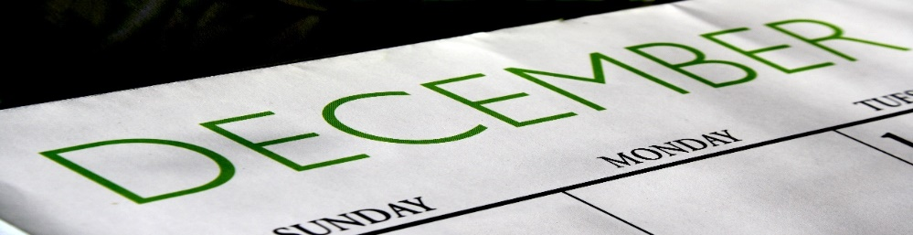
McCarty Monthly
December

Wednesday, December 4th Winter Reading Night-6:30 pm
Spirit Week –
Monday, December 16th Class Colors -
Kindergarten – Blue
1st grade - Green
2nd grade – Yellow
3rd grade – Pink
4th grade – Gold
5th grade – Purple
Tuesday, December 17th Sports Day
Wednesday, December 18th PJ Day
Thursday, December 19th Thinking Cap Thursday
Friday, December 20th Ugly Sweater, Holiday Wear
End of 2nd quarter
Monday, December 23-Friday, January 3rd Winter Break – No School

