Junior Great Books
The Fry PTA is once again sponsoring the Junior Great Books (JGB) program for 2nd to 5th grade students beginning in January. For those not familiar with the program, JGB is similar to a book club in which students read short stories from a specific book and then meet to discuss what they have read. JGB combines interpretive discussion and activities with outstanding literature to encourage students to think critically as they read. JGB is a wonderful program for students who enjoy reading and discussing stories. The stories are sometimes challenging and may require parental assistance. The student is asked to read each week’s assigned story twice. It is acceptable for you to read aloud together.
The sessions will be held on Wednesdays during the student’s lunch and recess period. Please be sure your child is willing to give up recess for this commitment. Due to time constraints, we ask that students bring lunch from home on JGB days (as opposed to getting hot lunch).
The program begins on January 22, 2020, and lasts 9 weeks. Because class sizes are limited to 8-10 students, names will be chosen on a first-come, first-served basis. If your child would like to participate, please complete and return the attached form to his or her classroom teacher along with the appropriate participation fee ($25.00 if new book is needed or $5.00 if book is not needed. Please be aware that there is a limited supply of used books available for 2nd grade only). Please do not staple the check to the form. The deadline for submission of the forms is Friday, December 20, 2019.
You will receive an email confirming your child’s participation in the program in early January. If you have any questions, please contact:
Latoya Campbell at latoyaecampbell@gmail.com or Avani Desai at ajd1979@yahoo.com

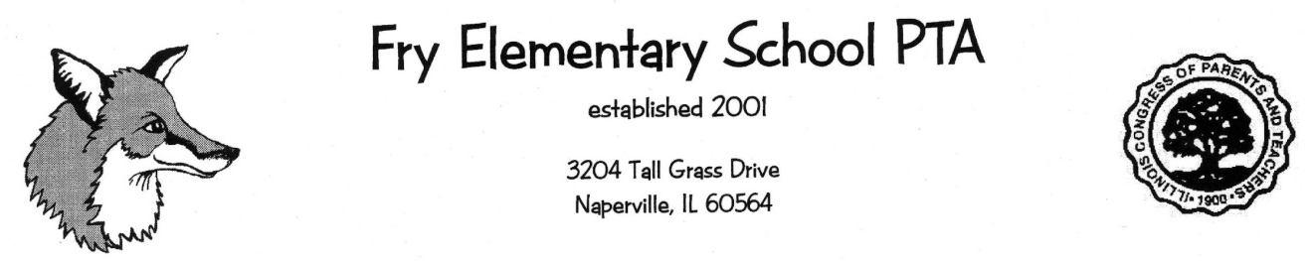
Student Name________________________________ Gender (circle) M or F
Teacher Name & Grade Level_________________________________________
Email address____________________________________________________
Parents’ Names___________________________________________________
Home phone #_________________________Cell #_____________________
*************************************************************************
Does your child have food allergies? Yes or No. ______ (If yes, please list below)
______________________________________________________________
Are these allergies listed with the school nurse?_____________ Yes or No.
**************************************************************************
Each child will need a Junior Great Book (new or used).
_______I need to order a NEW book (cost $25)
_______I have the book and do not need a new one. (cost $5)
_______I would like a used copy - available only for 2nd grade ($5, supply is limited so this is first come, first served)
_________________________________________________(parent signature)
Please enclose a check, with your child’s name on it, for $25 (needing a book) or $5 (not needing a book) made out to FRY PTA. Each child requires their own form and check. If you have multiple children, please submit each separately. Return this page with a check in an envelope to your child’s teacher by December 20,2019, Please do NOT staple the check to the form.

