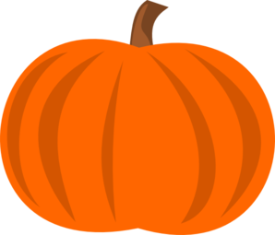
Georgetown Pumpkin Decorating Contest –
REMOTELY, of course!
Are we going to forget a fun tradition this year just because we are not in school? NO WAY! Then I guess we will have to do it REMOTE! We invite all ages to decorate a pumpkin resembling their favorite book character. It's easy and fun for the whole family!
Contest Rules:
Pumpkins should represent a favorite book character. To enter the contest please send a picture of the completed pumpkin (NO NAMES OR HUMANS IN THE PICTURE, PLEASE) along with the following details:
- Title and author of the book
- Book character
- Family Name along with Children(s) name with class
Email these items to: vicki_pattermann@ipsd.org no later than October 23, 2020

**We recommend getting the book information first before even starting to decorate the pumpkin** We are asking for no carved pumpkins just like in past contests. We have loved seeing the imagination of our students and families decorating pumpkins. We will not be able to enter in any carved pumpkins. Thanks for your cooperation. One pumpkin entry per household. Work on a design as a family! Let your creativity soar! Here are some suggestions for decorating: paint or color with markers--acrylic paints or permanent markers work best. Watercolors tend to run. Yarn, construction paper, pipe cleaners, paste or glue, etc. Do not write your name anywhere on the pumpkin. We will take your pumpkin picture along with entry details when received by Mrs. Pattermann, and it will be assigned a number for our vote.
Important Dates:
October 23-All Entries Due to Mrs. Pattermann
NO LATE ENTRIES WILL BE ACCEPTED! Please include all 5 details (see above) along with a picture of your pumpkin when entering. PLEASE ONLY HAVE THE PICTURE OF THE PUMPKIN. NO NAMES OR HUMANS
October 26th-28th Judging will take place via a Google Form.
October 30st Winners will be announced.

Prizes-Gift Certificates for Books!
1st Place -$20.00, 2nd Place - $15.00, 3rd Place - $5.00

