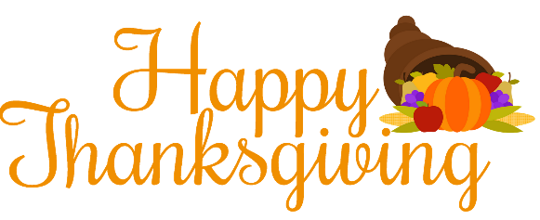
Hello Fry Families,

Even though students are not physically in the school building, we would like to continue our annual tradition of helping some District 204 families in need.

We will be collecting the items below from November 16th-19th.
All donations will go to local 204 students/families.

The items below can be donated during our student materials pick-up next week. Please look for the large green bins at the center of the loop drive.

In order to collect a variety of items, please note the suggestions below:

Primary Grades (K-2)
Boxed Items only please: jello or pudding, mac-n-cheese, stuffing, mashed potatoes, rice, muffin or bread mix, crackers

Intermediate Grades (3-5)
canned cranberry sauce or fruit, canned vegetables
salad dressing (plastic bottles only)
cake/brownie/cookie mix, chocolate chips, canned frosting

Thank you for giving and for making Thanksgiving happen for others! We appreciate your support!
The Fry Staff

