Support our School!
Order Books at our
Anderson’s Virtual Book Fair
November 23-December 6
Discover
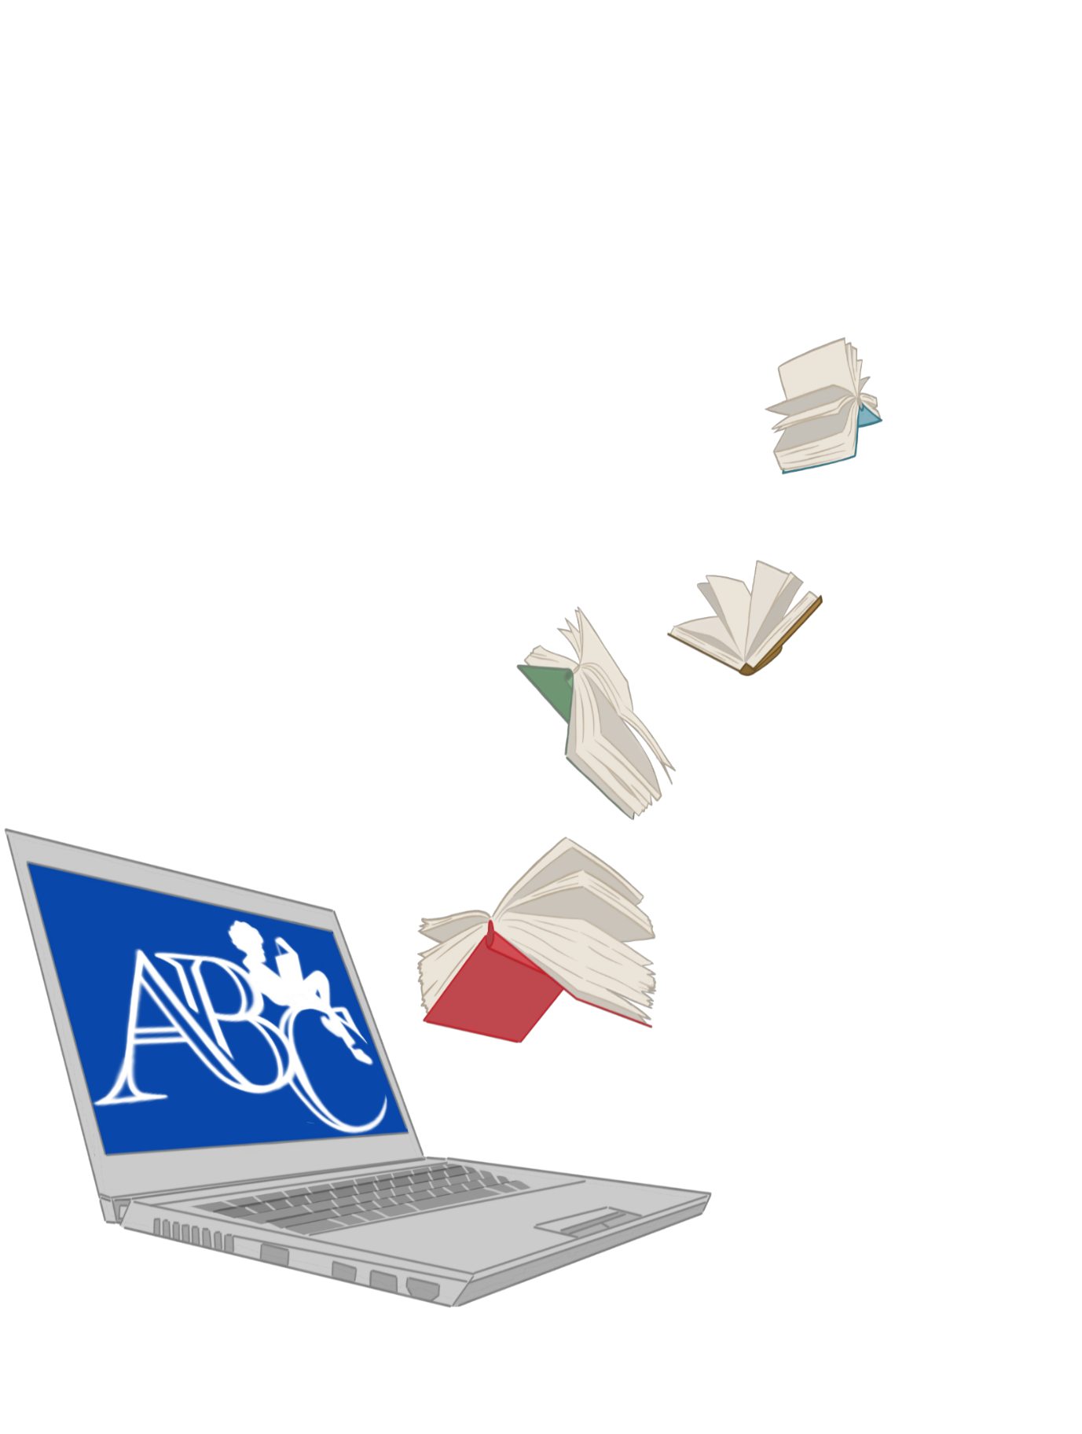
*The Best Selection
*New Releases
*Best Literature
*Reading Books reduces screen time
*Order anytime from anywhere
*Best Opportunity to raise funds for our school
It’s easy, here’s how:
Go to www.abcfairs.com
Click on the categories that you are interested in. (Can’t find a book, use the search bar.)
Click (Add to Cart) for each book you would like to purchase.
Fill in the required fields on the Checkout page, including your School Name and City. Please include your Student and Teacher’s names.
Please let us know if you would like to pick up the books and where. Other Shipping options are available.
Review and complete your On-Line Order!
Last but not least…READ!

Please contact us with any questions, customerservice@abcfairs.com
or call us at 630/820-0044.

