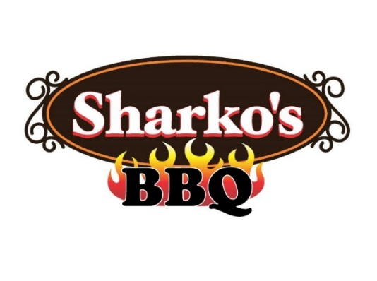

Graham Elementary School

When: Thursday January 7th 2021

Time: “Pig Up” and Go & Dine-In, 11am to 7:30 pm
Location: Sharko’s BBQ, SharkosBBQ.com, 630-717-7BBQ (7227)
4931 S. RT 59, Naperville, Corner 111th and RT 59

As featured on “Chicago’s Best”
Rated Top Restaurants in Naperville on Trip Advisor

"Just mention this flyer to the cashier and 20% of Graham Sales will go back to the PTA"

