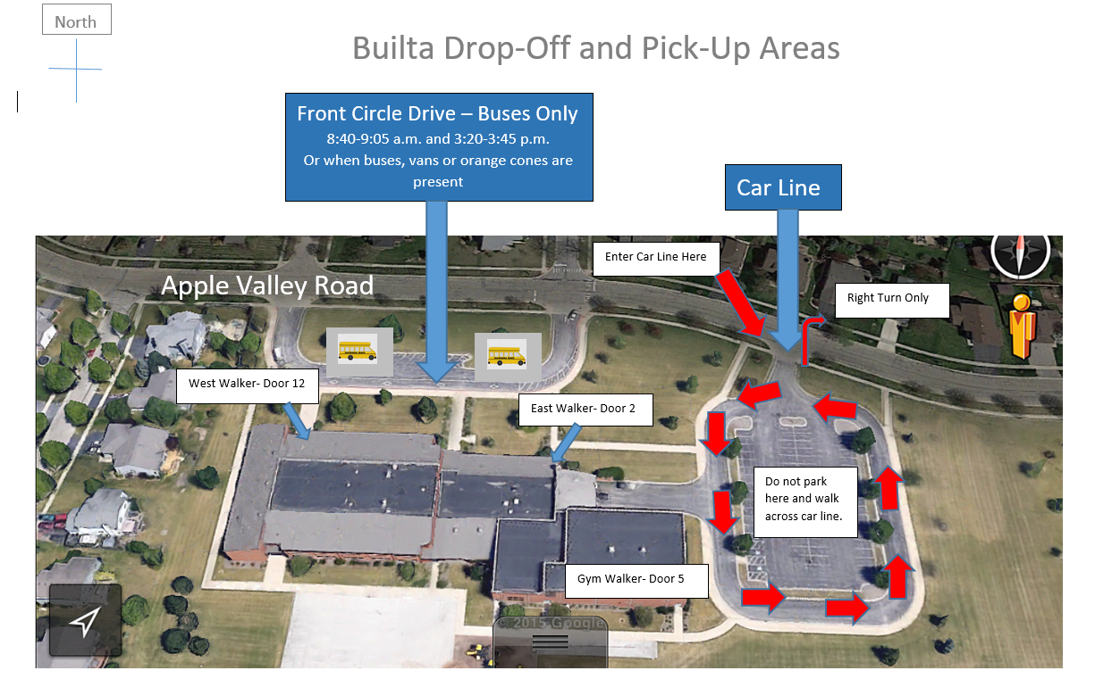

Student First and Last Name
Teacher Name
My child will be dismissed as follows unless written notification of change is given (choose one):
____ Bus Rider (Only if child qualifies based on home address) – Will line up in multipurpose room.
____ Car Line rider- Will line up in gym and be picked up in car line.
____ West Walker – Will line up in hallway and exit at Door 12.
_____ East Walker – Will line up in hallway and exit at Door 2
____ Gym Walker – Will line up in Gym and exit at Door 5.
____ Day Care Name of Day Care Provider (___________________________________)
This will be my child’s daily plan for dismissal unless I notify my child’s teacher or the office of a change in writing.
_____________________________________ ________________
Parent/Guardian Signature Date

