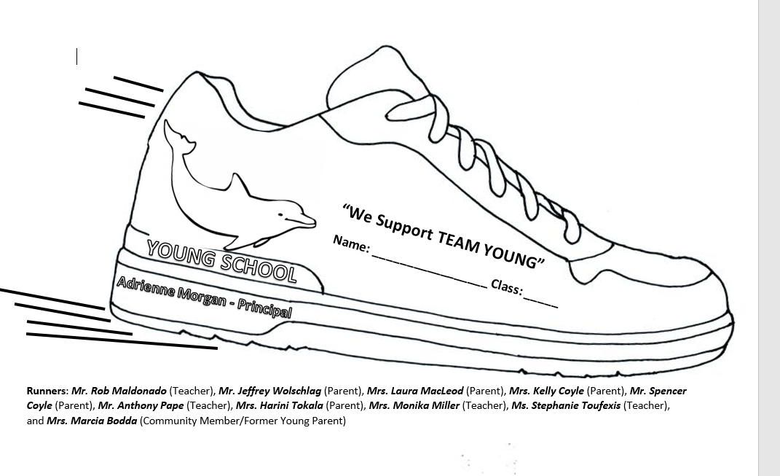

**10/22/17**

Monika Miller

Jeffrey Wolschlag

Harini Tokala

Naga Ramesh Nekkanti

Rob Maldonado

Venugopal Kosanam

Marcia Bodda

Hemant Malhotra

Laura MacLeod

Anthony Pape