Houston School Supplies Needed

Making a difference in education for students. One donated item at a time!
DONATE September 11 – 22

www.supplybucket.com
Supplies Needed

  - #2 Pencils
  - 12” Ruler
  - Highlighters
  - Crayons
  - Washable Markers
  - Color Pencils
  - Glue Sticks
  - Composition Notebooks
  - Loose Leaf Paper
  - Index Cards
  - Red/Blue/Black Pens
  - 3 Ring Binders
  - Mechanical Pencils
  - 2 Pocket Folders
  - Dry Erase Markers
  - Scotch Tape
  - Tissues
  - Erasers
  - Correction Fluid
  - Compass/Protractors
  - Post-it Notes
  - Graph Paper
  - Back Packs

  - Pencil case

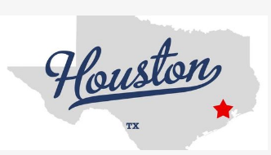
Thank you to our Partners
Mayor Irvin’s Office
Mayor Turner’s Office and Houston ISD
Indian Prairie School District 204

