National PTA Reflections Program
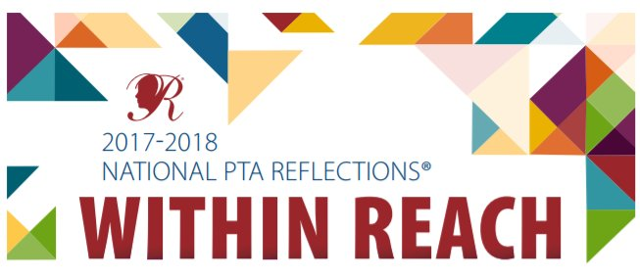

It is Reflections time!! Encourage your Nancy Young Artist to create an original piece of art and enter the
PTA Reflections Contest.
The theme for the 2017-2018 school year is:

“Within Reach”

All information about Reflections, including specific rules for each category can be found under the Reflections Tab, under PTA at: www.young.ipsd.org The Summary of Rules for Participation is found below and the Student Entry Form is located on the back of this sheet. The rules for some of the categories are very specific. Please refer to the website for all of the details. In order to advance to District 204, the DuPage West Region, the State of Illinois…and beyond, all works of art must comply with the specific rules for that category.

Dance Choreography: Solo and ensemble works of all dance styles are accepted. Entrant must be the choreographer and may also be the performer, or one of the performers. If background music is used, cite it on the entry form. Video file must not exceed 5 min. and 1 GB in size. Accepted formats: AVI, FLV, WMV, MOV, MP4.

Film Production: Accepted short film styles include: Animation, narrative, documentary, experimental or media presentation. Use of PowerPoint is prohibited. Entrant must be the screenwriter, cinematographer, editor and producer. If background music is used, cite it on the entry form. Video file must not exceed 5 min. and 1 GB in size. Accepted formats: AVI, FLV, WMV, MOV, MP4.

Literature: Accepted forms of fiction and nonfiction include: Prose, poetry, reflective essay, screen play and play script, narrative, and short story. Entrants may write in their primary language as long as an interpretive English translation is also attached. Use of copyrighted material is prohibited. Writing must not exceed 2,000 words and may be handwritten or typed. Accepted formats: Single-sided print on 8 ½x11” paper, PDF file.

Music Composition: All music styles and combinations of instrumentation are accepted. Entrant must be the composer and may also be the performer, or one of the performers. Use of copyrighted material is prohibited. Audio file must not exceed 5 min. and 1 GB in size. Accepted formats: MP3, WMA, WAV, ACC, FLAC.

Photography: Photo must be a single print/digital image. Collages and collections of photos are not accepted. Entrant must be the photographer and may use a variety of digital editing techniques including but not limited to, multiple exposure, negative sandwich and photogram. Use of copyrighted material is prohibited. Print image dimensions must be no smaller than 3x5 inches and no larger than 8x10 inches. Accepted print formats: Mounted on mat or poster board no larger than 11x14 inches. Framed prints are not accepted. Digital image dimensions must be at least 640x960 (pixels) and 300 dpi (resolution). Accepted file formats: JPEG, JPG, GIF, PNG.

Visual Arts: Works of both fine and design arts are accepted, including but not limited to: architectural drawing, ceramics, collage, computer generated images and graphics, crafts, drawing, mixed media, painting, printmaking and sculpture. Use of copyrighted material is prohibited. 2D artworks must be mounted on sturdy material and no larger than 24x30 inches with matting. Framed entries are not accepted. Include one digital image of artwork with your submission. 3D artwork submissions must contain 3 digital images of artwork at different angles. Image(s) are used for artwork identification, judging and exhibition purposes. Note: The decision to accept submissions of 3D art (ceramics, sculpture, or collage) in the visual arts category will be left to each individual local PTA.
Students who identify as having a disability and may receive services under IDEA or ADA: Section 504 may enter in the Special Artist Division or grade division most closely aligned to their functional abilities. The Special Artist Division welcomes all grades and all abilities and offers non-artistic accommodations (e.g. adaptive technology; transcribing; holding a camera) for students to participate fully in PTA Reflections. Student assistants must refrain from being involved in the artistic process (e.g. developing an artist statement, choreography, music lyrics, storyboards, etc. Student recognition and awards are announced as part of the Special Artist Division.
Questions Please contact Priti Amin at Hicmin@yahoo.com Entries due to the NYE office by Oct 20th

