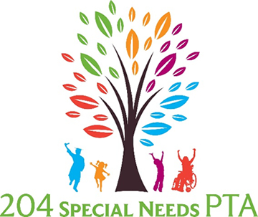  Thursday Sept. 28th  9th annual special needs resource fair 6pm-8pm  Peterson Elementary School  4008 Chinaberry Lane  Naperville, IL 60564 | Free and open to the public!  ────  Receive information on products and services for children & adults with special needs!  ────  Discover community resources!  ────  A great variety of special needs vendors for all ages and abilities!  ────  Don’t miss out on this amazing event!  Questions: IPSN PTA  ipsnpta@gmail.com  Telephone  Web Address  Dates and Times

