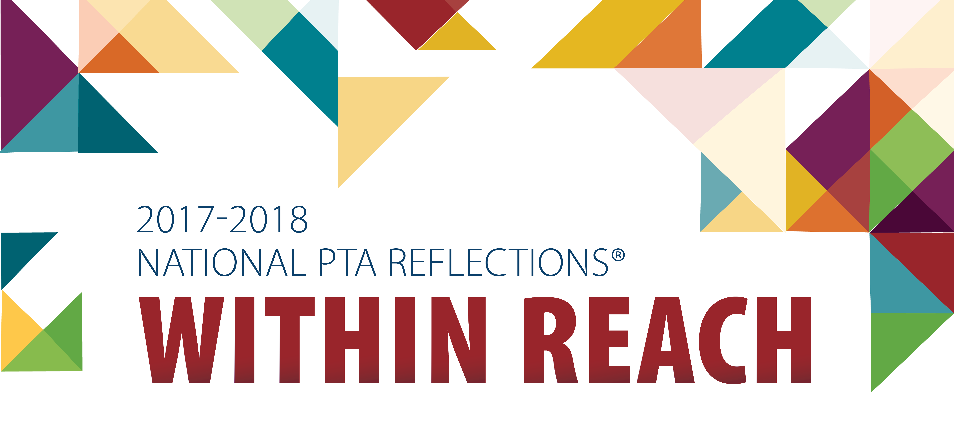
2017-2018 THEME
Be a Part of PTA’s Reflections® Program
Entries from all grades and all abilities welcome.
THEME

Dance ChoreographyFilm ProductionLiterature
Music CompositionPhotographyVisual Arts
Submit entries to
Main Office
at Main & Brikett
by 3:30 Wednesday
November 1, 2017

See the PTSA web site for details
or contact Crystal Nelson at crystalnelson103@gmail.com

