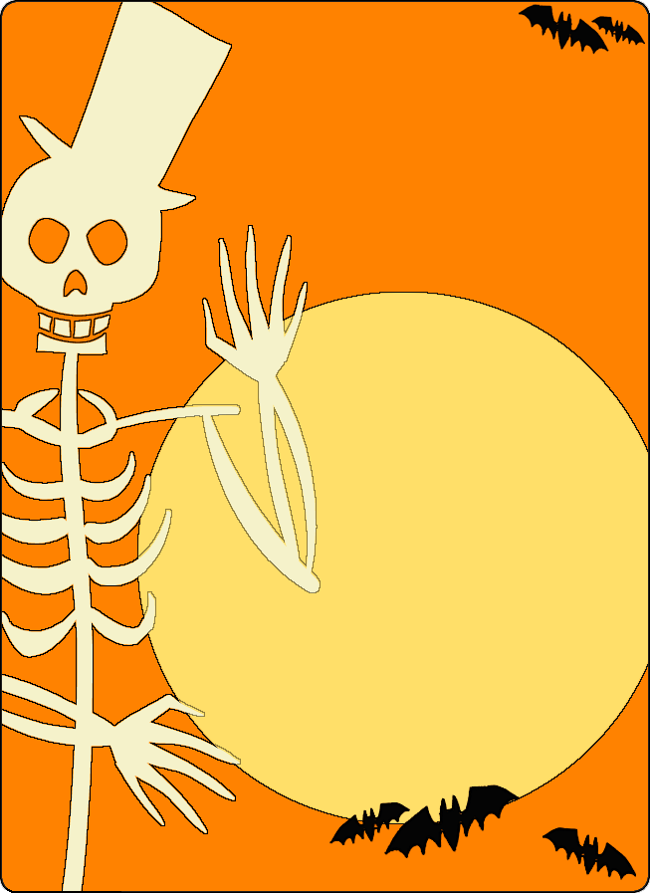
Family fun Bingo Night
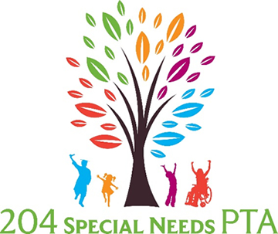

October 26 at 6:30-8:30

Still Middle School

787 Meadowridge Dr. Aurora, IL
Please join us for some ghoulish games, freaky fun, and spooky snacks!
Costumes are encouraged.
Giveaways, door prizes, fun games, Bingo, delicious treats and more!

