2017 Brookdale Teal Pumpkin Project Map
tinyurl.com/brookdaletpp2017
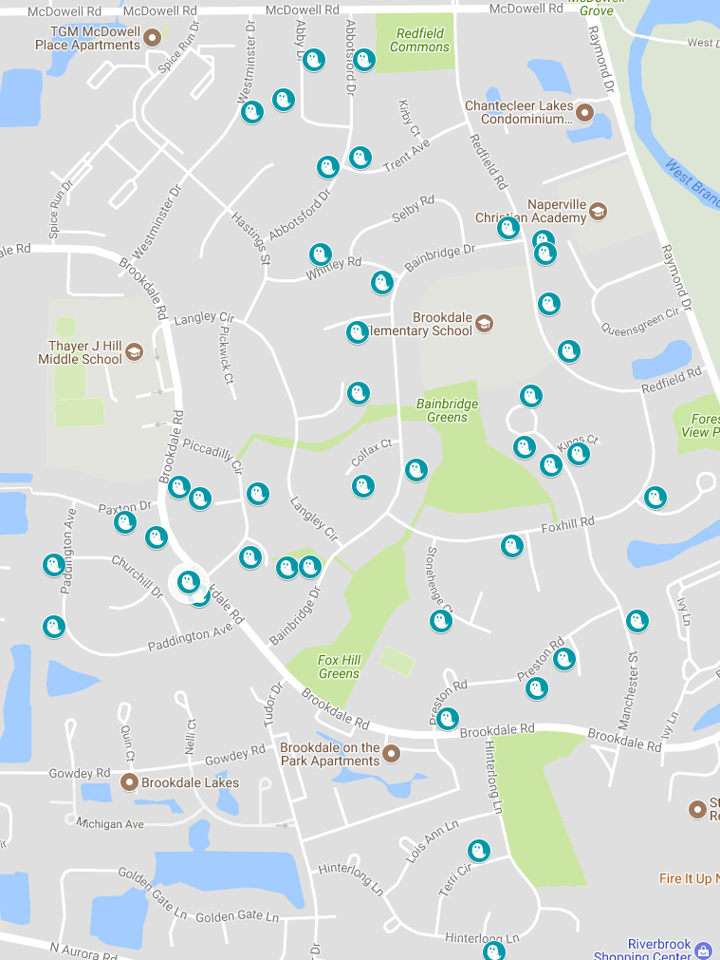

The following Brookdale homes will be offering
allergy-safe toys/treats for Trick-or-Treaters this year.
For the most current list, visit tinyurl.com/brookdaletpp2017

1613 Abby Dr.
1624 Abby Dr.
1539 Abbotsford Dr.
1542 Abbotsford Dr.
1556 Abbotsford Dr.
1568 Abbotsford Dr.
1608 Albermarie Ct.
933 Bainbridge Dr.
1040 Bainbridge Dr.
863 Balton Ct.
1551 Brookdale Rd.
1756 Brookdale Rd.
1764 Brookdale Rd.
1788 Brookdale Rd.
1807 Brookdale Rd.
1507 Colfax Ct.
1614 Colfax Ct.
1598 Derby Ct.
1434 Foxhill Rd.
1516 Foxhill Rd.
1602 Hinterlong Ln.
904 Manchester
1036 Manchester Ct.
1037 Manchester Ct.
1105 Manchester Ct.
1116 Manchester Ct.
1836 Paddington Ave.
1864 Paddington Ave.
1748 Paxton Dr.
1112 Piccadilly Cir.
1132 Piccadilly Cir.
1528 Preston Rd.
1709 Prince Ct.
1108 Queens Ct.
1195 Redfield Rd.
1211 Redfield Rd.
1227 Redfield Rd.
1231 Redfield Rd.
1240 Redfield Rd.
919 Stonehenge Ct.
1611 Terri Cir.
1624 Westminster Dr.
1592 Whitley Rd.
1609 Whitley Rd.

