­­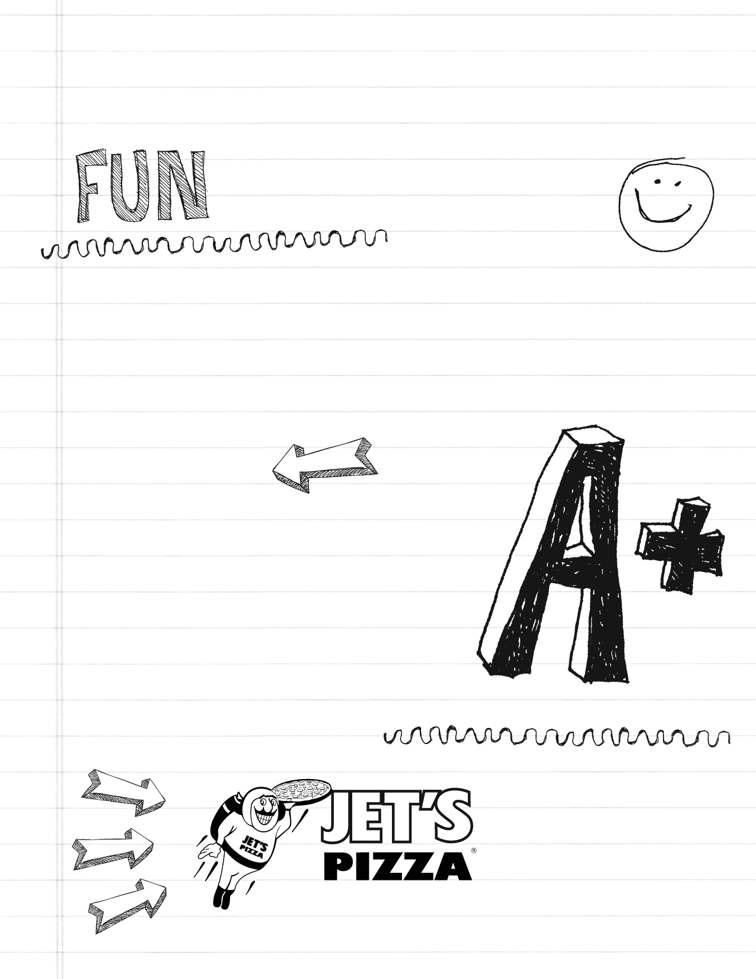

South Naperville

3344 S. Route 59

(South of McDonalds)

630-904-7777

Join up with Jet’s Pizza to raise money for Fry Elementary School.

Join us by enjoying any of their superior options, including a pizza from dough that’s made fresh daily and topped with only the finest and highest quality ingredients available... and help our school at the same time!

For every order, Jet’s Pizza will donate a percentage of that sale back to Kingsley Elementary School, which funds important schoold programs like the Science Fair and STEAM day.

It’s as easy as 1, 2, 3...!

• Call the South Naperville location at **630-904-7777**

• IMPORTANT – Before ordering, please say “This is an Pizza Night Order for Fry Elementary”

• The benefit is good ALL DAY, for CARRY-OUT or DELIVERY!

That’s it! Now you have the satisfaction knowing that part of your purchase will benefit Kingsley Elementary ..

Let Jet’s do the cooking on Wednesday, Nov. 15!

*Regular Store Hours:

Sun -Thur: 10am-10pm

Fri - Sat: 10am-11pm

Date:11/15/17

# Help Raise Money for Fry Elementary PTA!

draiser Program

Jet’s Pizza® Night