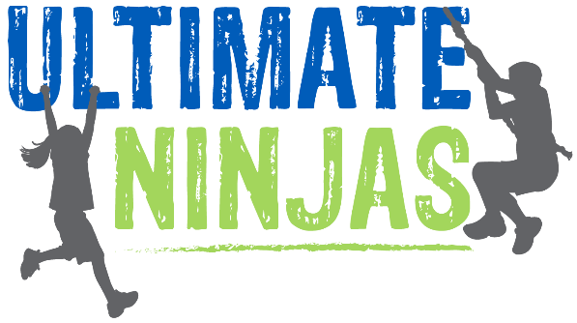
Have the ULTIMATE Day off school at
Ultimate Ninja Warriors!
Fry PTA is hosting the Ultimate day off at the New Ultimate Ninjas in Naperville on Tuesday, January 16!

Kids can test their strength on fun apparatus like the ropes course, salmon ladder and the warp wall. In order to make sure that everyone is able to fully participate, there is a maximum of 80 participants per session. Sign ups are first come first serve. Ultimate Ninja will also be donating a portion of the admission fee to Fry PTA!
The Fine Print:
Age: Participants must be 6 years old unless they are a registered kindergartner at Fry. We will be required to check enrollment for those under 6. (sibs & family are able to watch from the gallery and we will have crafts in the party room for younger sibs)
Sessions Times: & Fee:
The fee is $15/person and is non-refundable. Session times are either 11:30-1:00pm or 1:00-2:30pm
Reservations & Payment:
Reservations are first come first serve and are required. They can be made via this Signup Genius link: http://www.signupgenius.com/go/70a084ba8af2e5-frypta
Your reservation is not guaranteed until you have paid via Paypal. When using PayPal, use the fryschoolpta@gmail.com address, select the Friends and Family option, and list students name & grade in the notes area.
Waiver: Prior to the 16th, please fill out the online waiver at: http://ultimateninjas.com/waiver/
Footwear: All participants must wear closed toed shoes.
**Please note, this is not a drop off event. We understand groups of kids will want to go together. For emergency purposes, one adult must be on site at all times. PTA will not be providing supervision for either participants or non-participants. **
If you have questions please email Fry PTA at: fryfoxpta@gmail.com

