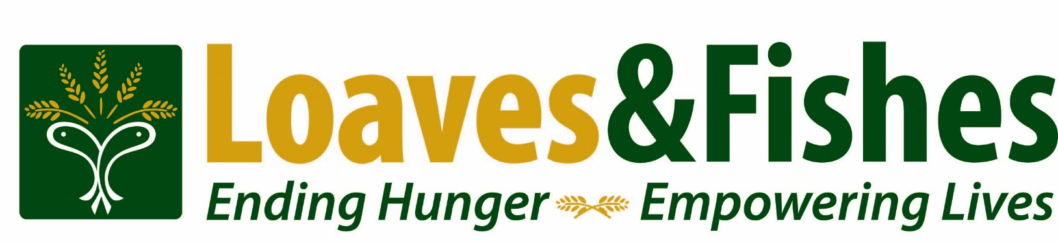

Students and Families-
Mustang Pride Leaders are partnering with Loaves and Fishes in Naperville to sponsor a food drive for families in need from February 15 until February 28. Our goal is to raise 500 pounds of food for local families.
There will be a donation box located in the LMC for donated items.
Loaves & Fishes is a local food pantry that have served over 18.000 people and provided over 3 million pounds of groceries in the past year.
Please bring in any of the following food items, although any donation is welcome:
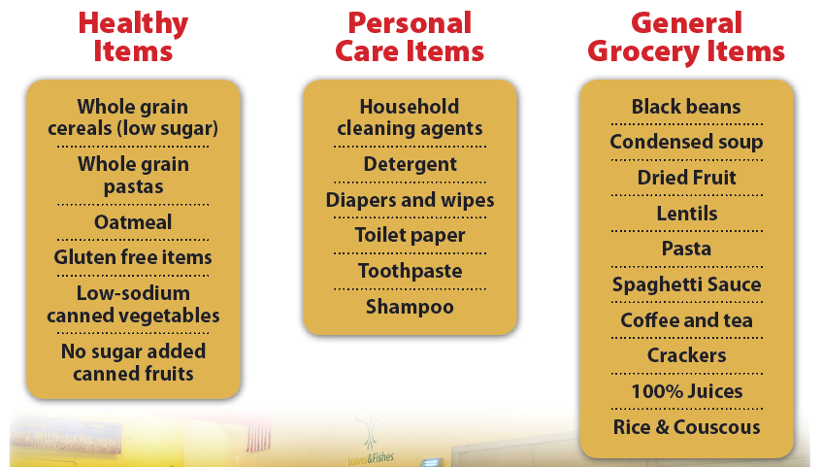

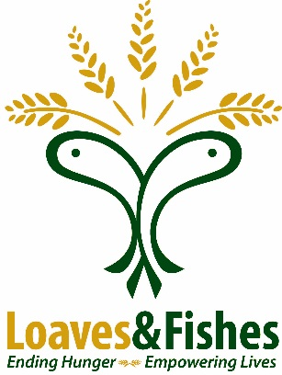
Thank you for supporting mission of the Mustang Pride Leaders of McCarty Elementary and Loaves and Fishes. We appreciate your help.
Respectfully,
Mr. Maldonado, Mr. Weis & Mrs. Sweder
Mustang Pride Sponsors

