Mini Mustang Preschool announces…
… openings for 2018-2019!
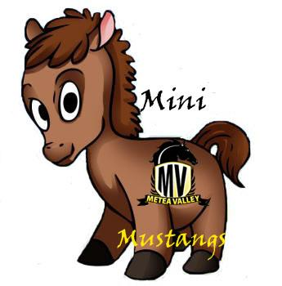

Metea Valley High School is proud to offer
The Mini Mustang Preschool
to our teachers & local families for the 2018-2019 school year.

The Mini Mustang Preschool is a lab-class offered to high school juniors and seniors who are exploring teaching as a career. The high school students develop lesson plans for 3 & 4 year olds that teach curricular subjects using age-appropriate teaching techniques. Preschoolers participate in activities that are planned around a weekly theme, while they explore different learning centers.

The preschool meets three days a week from approximately 9:20-11:30 a.m. Mini Mustang Preschool is for children:

- Who are 3 years old by September 1st
- Who are toilet trained
- Who are not regularly attending any other preschool program
- Whose family lives or works within Indian Prairie School District boundaries
- Who fulfill the IL State Medical Requirements
Registration is open for the 2018-2019 school year!
http://mvhs.ipsd.org/Subpage.aspx?id=399

or call (630) 375-5900 ext. 4376

