HUBBA BUBBA FUN FOR TEAM YOUNG!
(5/21-5/24)

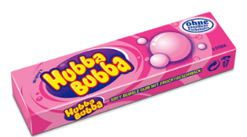

Dear Young Families,

Young is having a fun activity to support 2018 Team Young runners.

On Monday, May 21 – Thursday, May 24 Young students will have the opportunity to purchase Hubba Bubba Bubble Gum for 25/piece to chew during lunchtime. Students can purchase up to 4 pieces during their lunch period.

Students need to turn in a signed permission slip from a parent in order to purchase gum.

Happy Chewing!
Thank you for supporting Team Young

HUBBA BUBBA FUN FOR TEAM YOUNG!
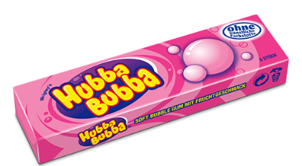

- Yes. My child ____________________________________________________________ in Class__________________________ can purchase gum.

_________________________________________________________________________________
Parent Signature

